As a culminating project, you'll be working with a dataset from ABC company, consisting of 458 rows and 9 columns. The company requires a comprehensive report detailing information about their employees across various teams. Your tasks include preprocessing the dataset, analyzing the data, and presenting your findings graphically. Here's a breakdown of what you need to do:  
  
Preprocessing:  
Correct the data in the "height" column by replacing it with random numbers between 150 and 180. Ensure data consistency and integrity before proceeding with analysis. (1 mark)  
  
Analysis Tasks:  
**1.**Determine the distribution of employees across each team and calculate the percentage split relative to the total number of employees. (2 marks)  
**2.**Segregate employees based on their positions within the company. (2 marks)  
**3.**Identify the predominant age group among employees. (2 marks)  
**4.**Discover which team and position have the highest salary expenditure. (2 marks)  
**5.**Investigate if there's any correlation between age and salary, and represent it visually. (2 marks)  
Data Story:  
Provide insights gained from the analysis, highlighting key trends, patterns, and correlations within the dataset. (3 marks)  
  
Timely Submission:  
Ensure timely submission of your project to earn an additional mark. (1 mark)  
  
Total Marks : 25  
  
By completing these tasks, you'll not only demonstrate your proficiency in Python programming but also your ability to analyze and communicate insights from real-world data.  
  
Download the dataset from this link.  
 <https://docs.google.com/spreadsheets/d/1VP9BE_eI2yl6uUHSm4mGiiwjRdoqCqnkcIjsv5Q2ex4/edit?usp=share_link>

**1.**Determine the distribution of employees across each team and calculate the percentage split relative to the total number of employees. (2 marks)

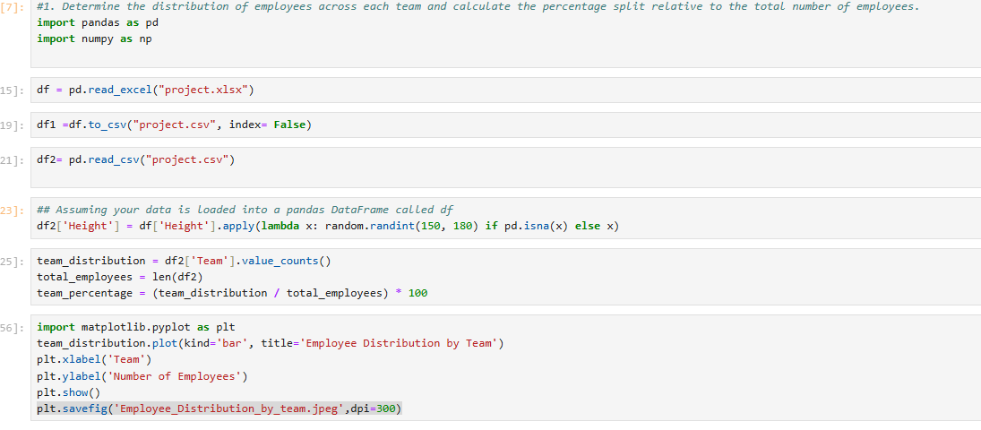

Graphical Representation:-

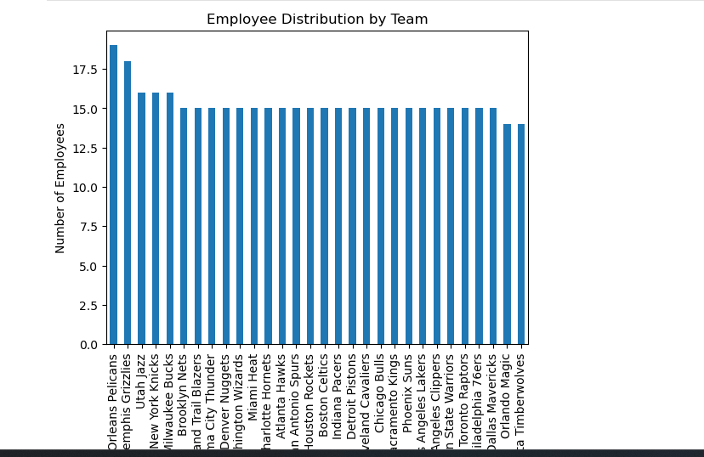

**2.**Segregate employees based on their positions within the company. (2 marks)

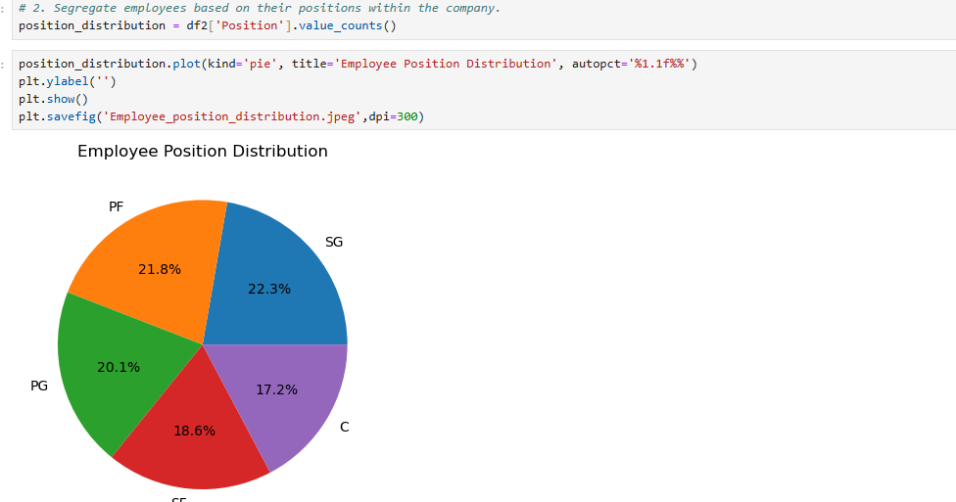

**3.**Identify the predominant age group among employees. (2 marks)

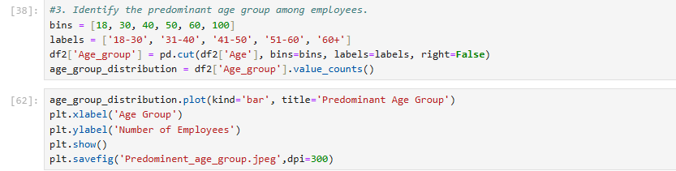 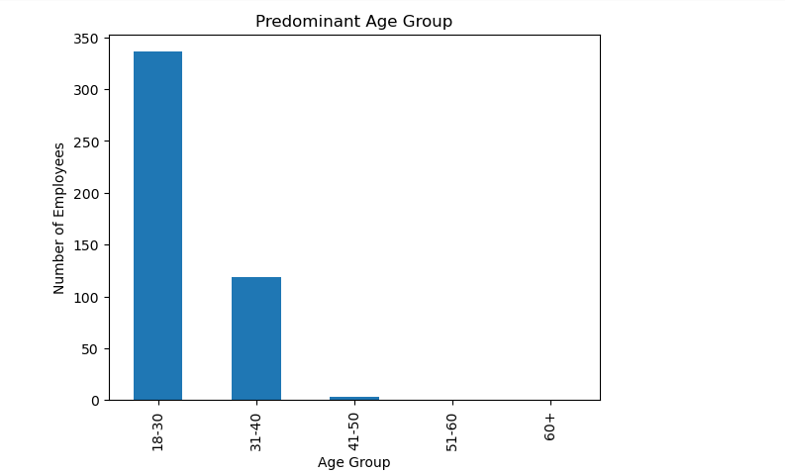

**4.**Discover which team and position have the highest salary expenditure. (2 marks)

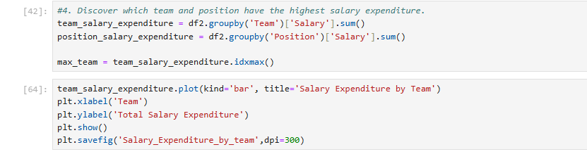

Graphical Representation:-

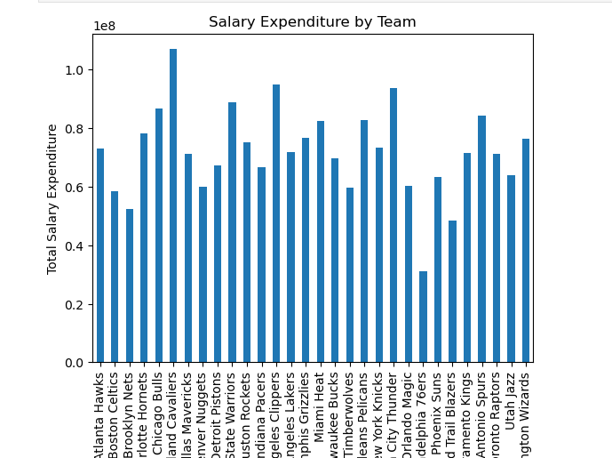

**5.**Investigate if there's any correlation between age and salary, and represent it visually. (2 marks)

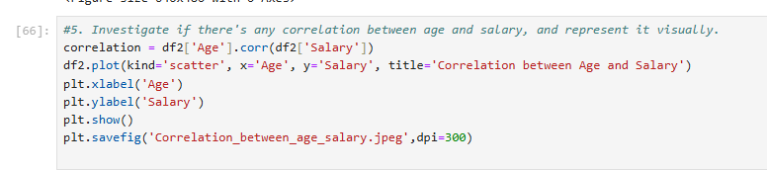

Graphical Representation:-

